**Little Brand DB Webpage Functionality**

By Viktoriya Marshova and Miguel Cano Gallo

**Main Page**

In this page, the user will have access to all the menus and the welcoming page of the store



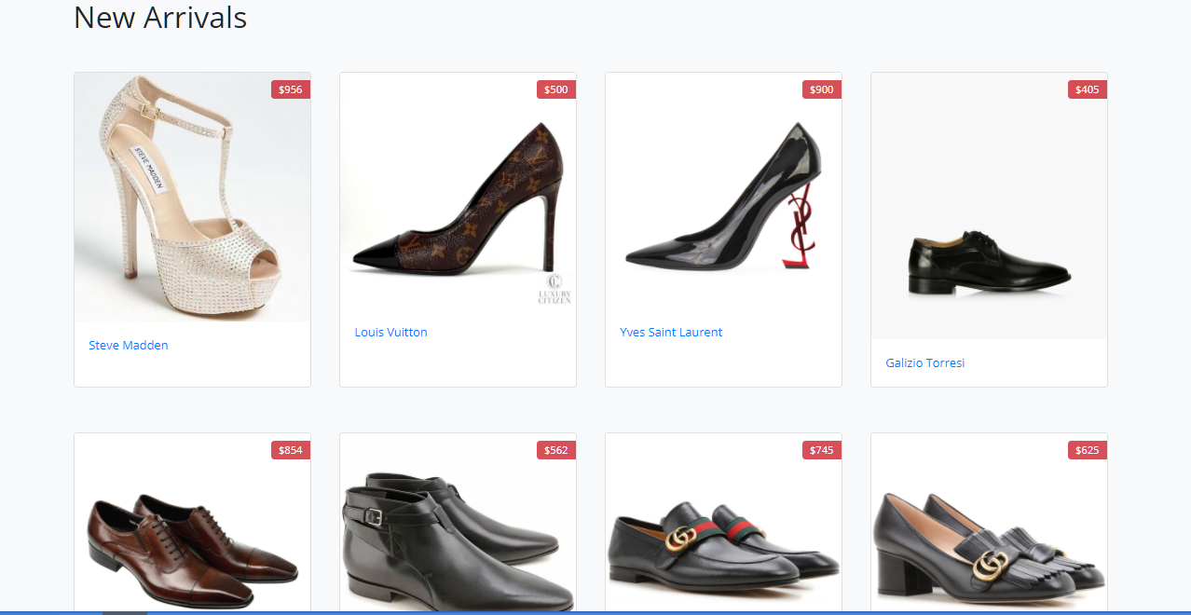

**Profile**

Once customers are signed into their profile, this screen will welcome them so they can see and update their information

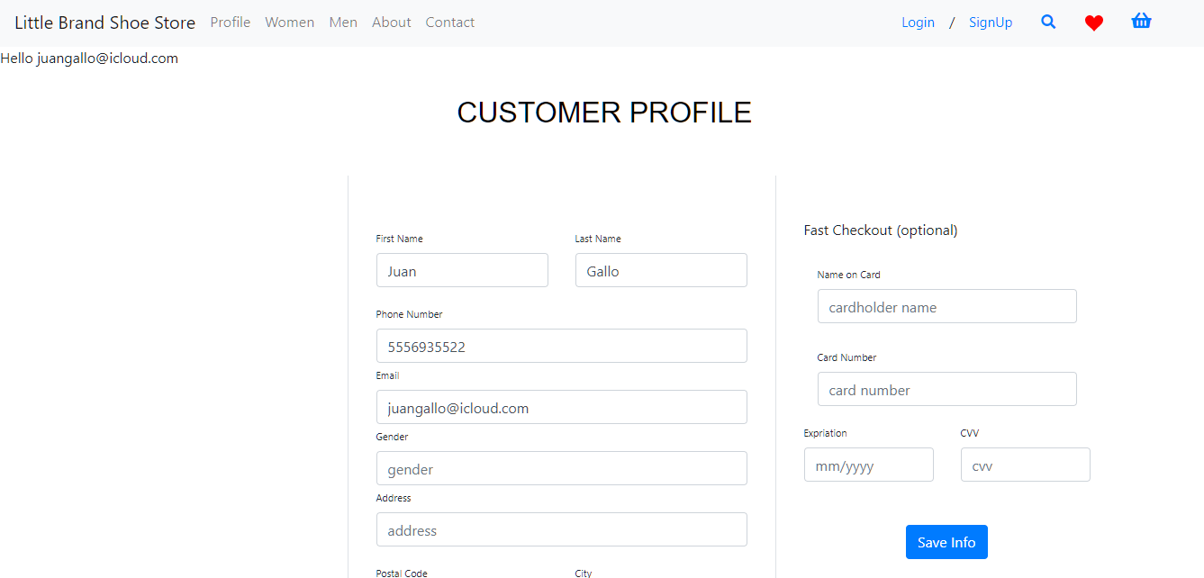

**Sing up**

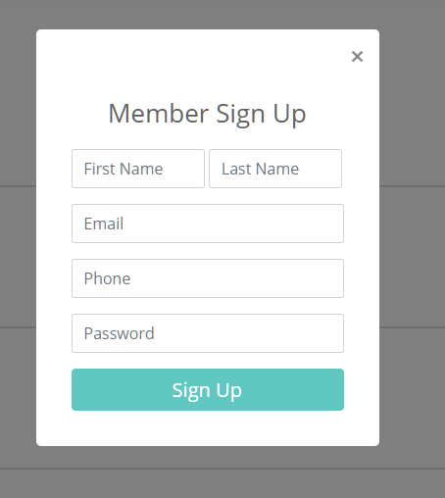

**Login**

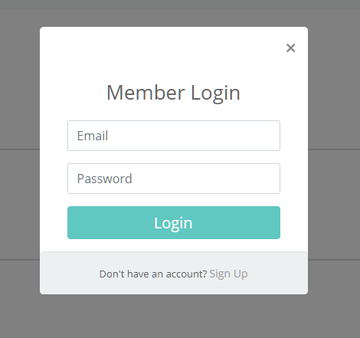

**Inventory**

The inventory is divided into two inventories: one for women and one for men. In here the customer will be able to sort the products as well as click on each product to see the information and add it to the cart.

**Women**

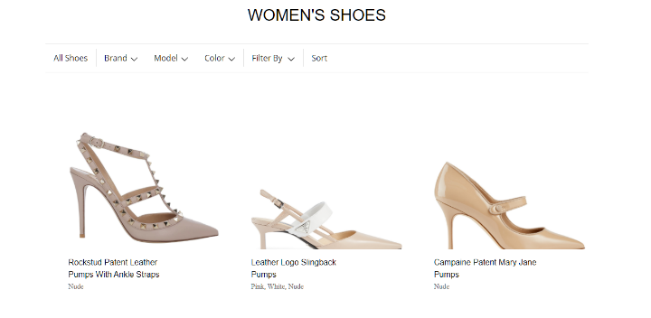

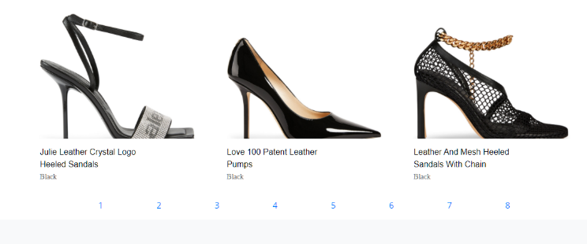

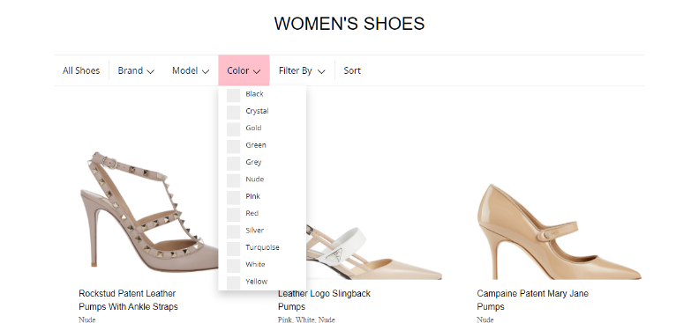

**Men**

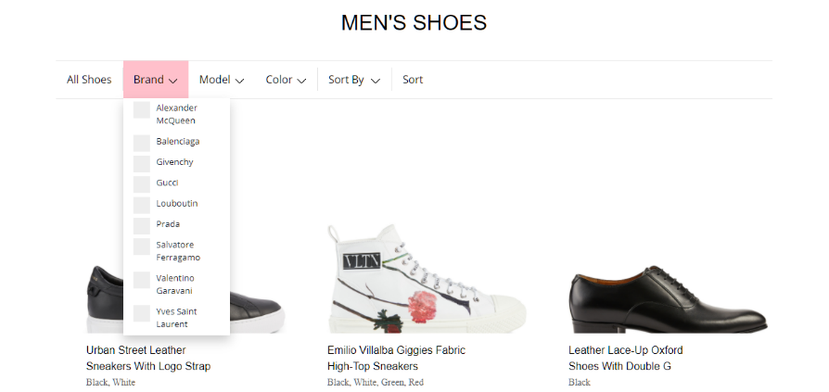

**Store**

This page then contains the information of the shoe that was selected.

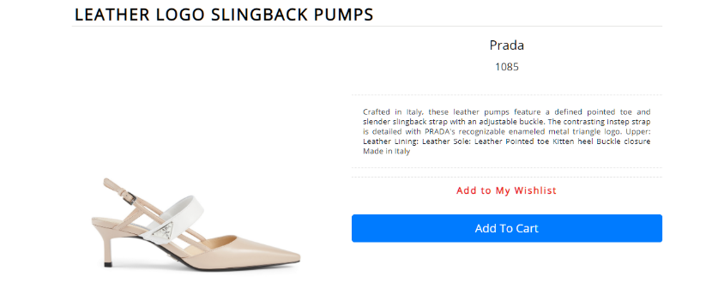

**Cart**

Once an item is selected and added to the cart, the customer can see the cart associated to their account in the cart page. There, they will be able to confirm their decision, see prices, and proceed to buy.

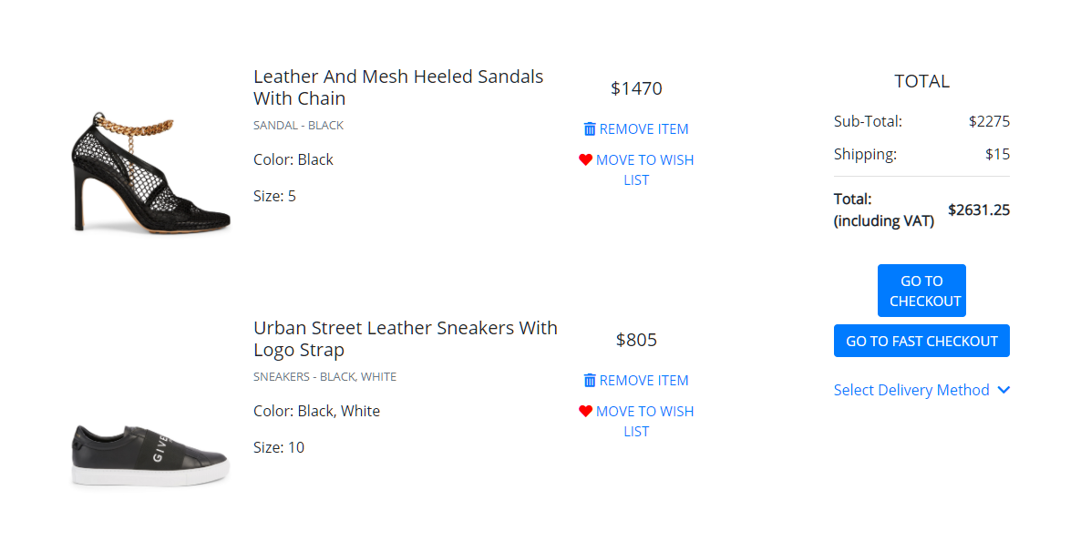

**About**

The about page contains information on all the brands that the store offers as well as on the store itself. Once someone click on a brand, they will see the information of said brand displayed on the side of the page.

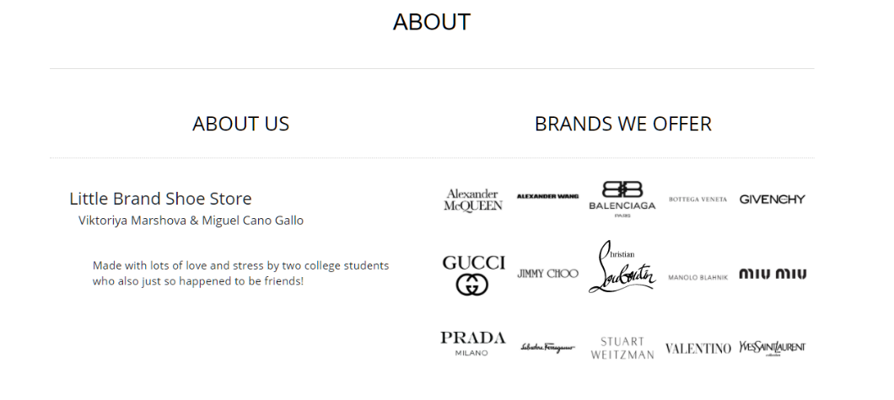

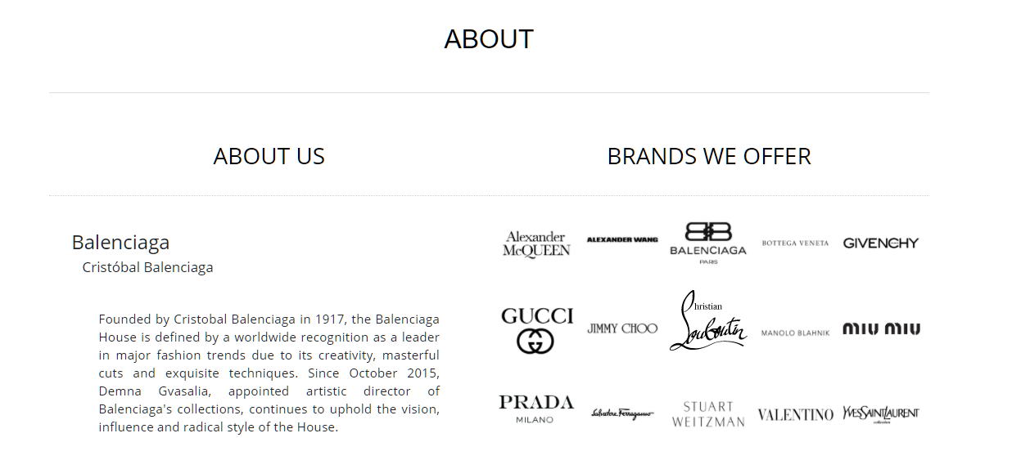



**Search**

When the user clicks on the search icon, they will then search the entire inventory to see the products that contain the word the user searched for.

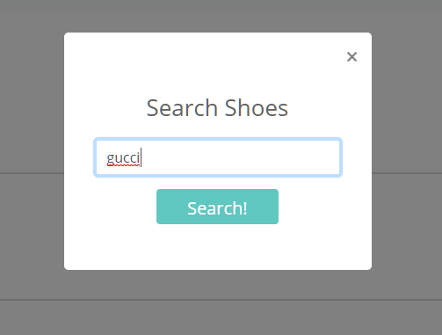

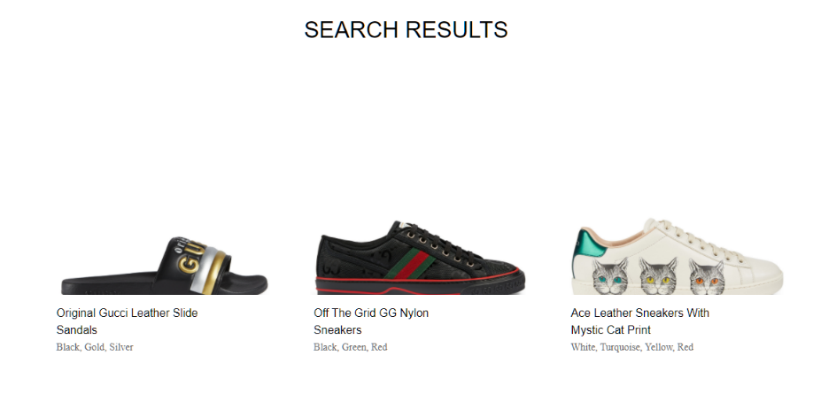

**Contact**

The page also includes a contact page in which a user can input their comments.

